**Screenshot - 01 for step No.4.1.1**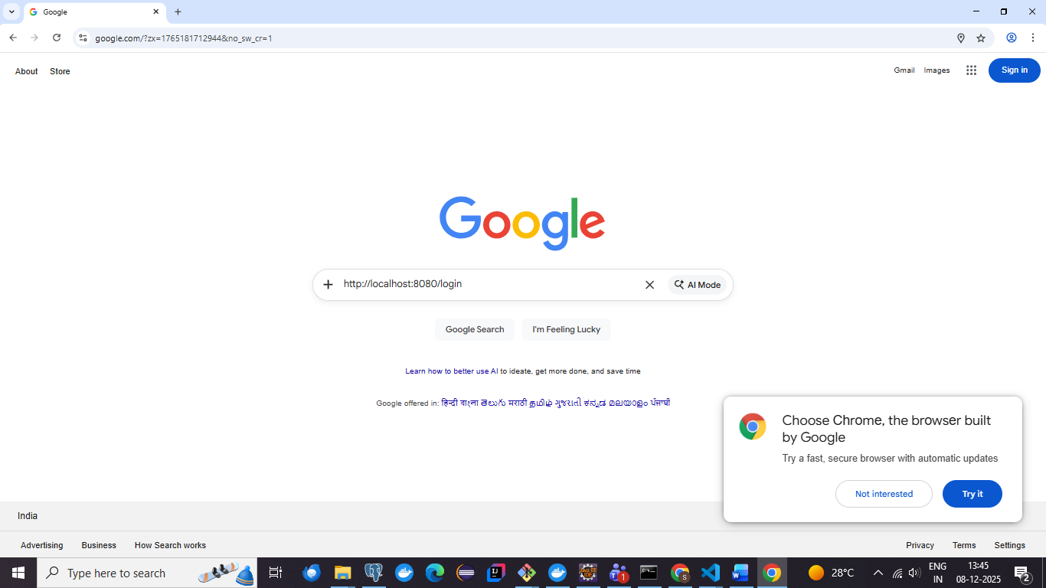

**Screenshot - 02 for step No.4.1.1**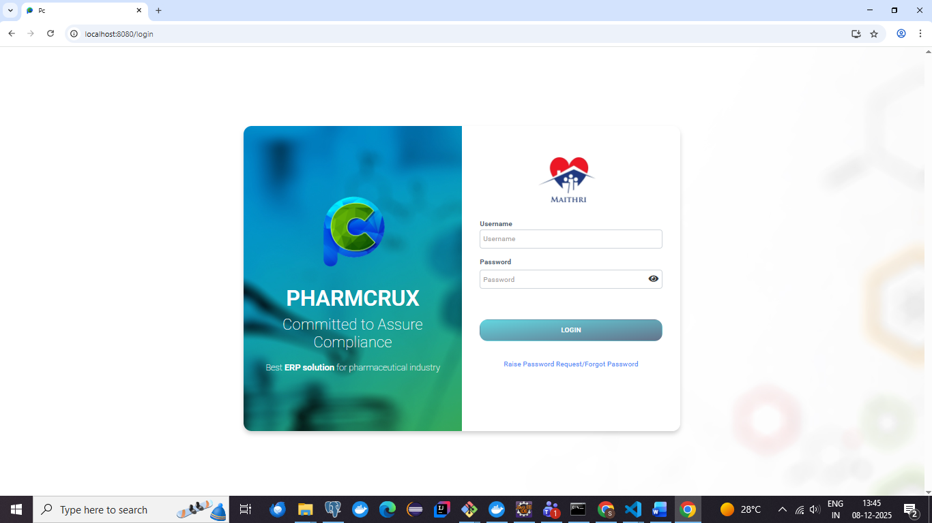

**Screenshot - 03 for step No.4.1.1**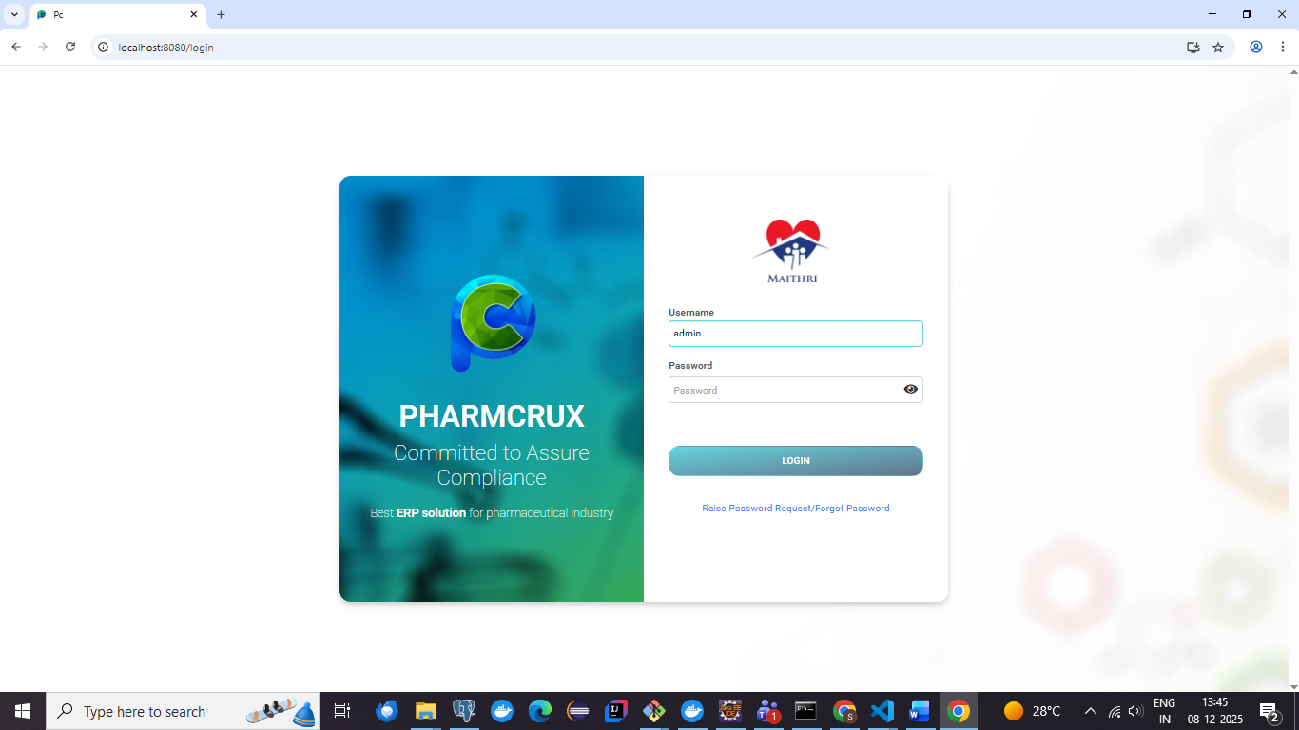

**Screenshot - 04 for step No.4.1.1**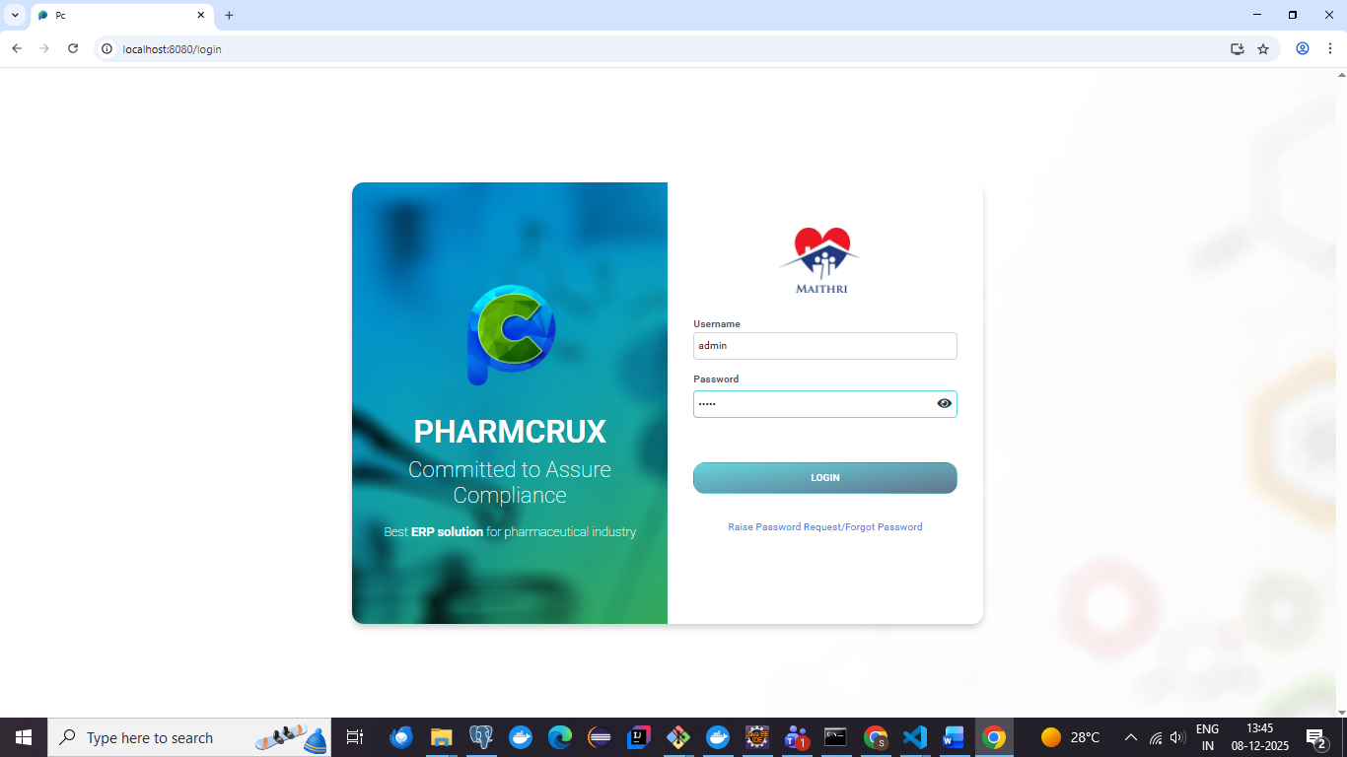

**Screenshot - 05 for step No.4.1.1**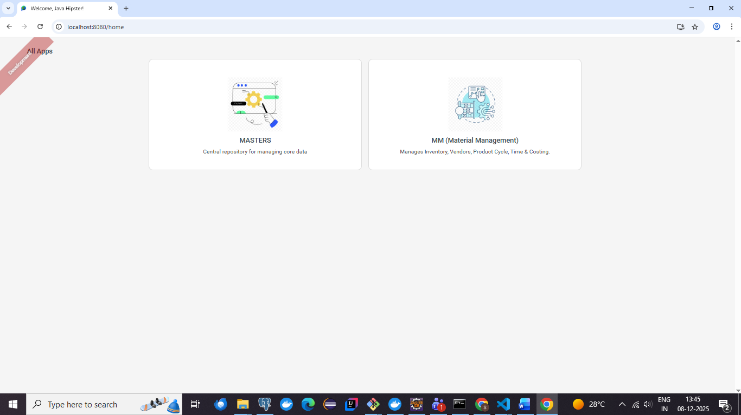

**Screenshot - 06 for step No.4.1.1**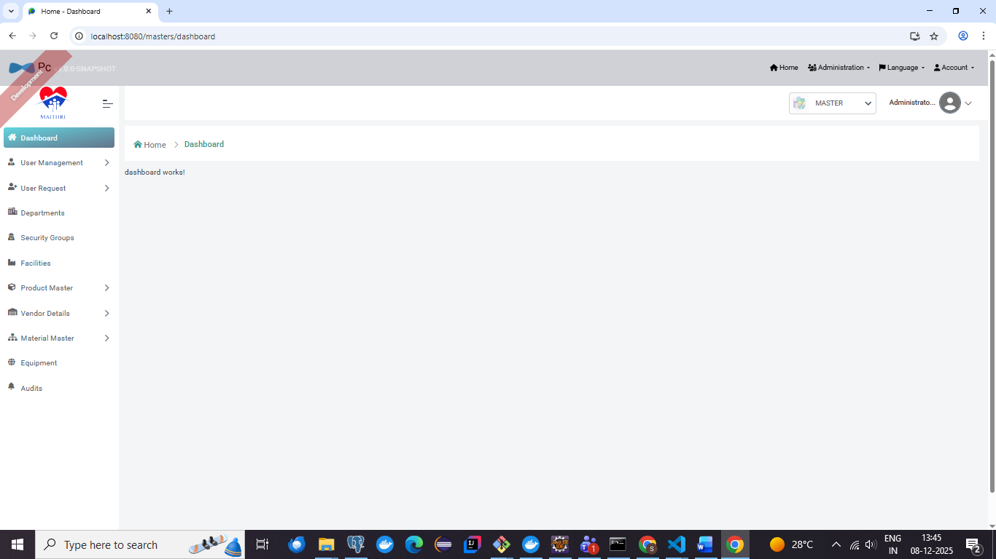

**Screenshot - 07 for step No.4.1.1**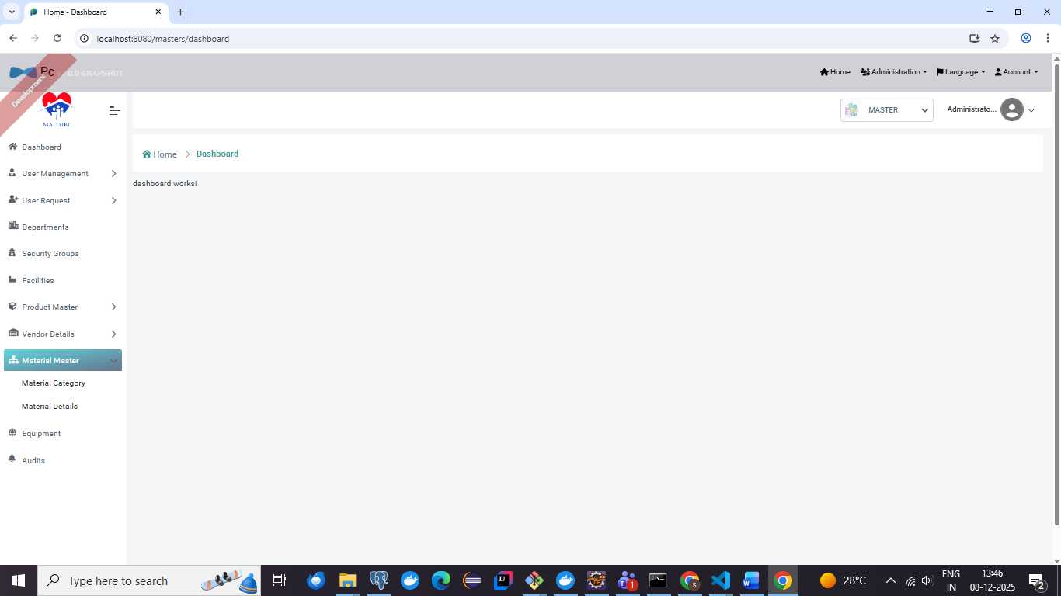

**Screenshot - 08 for step No.4.1.1**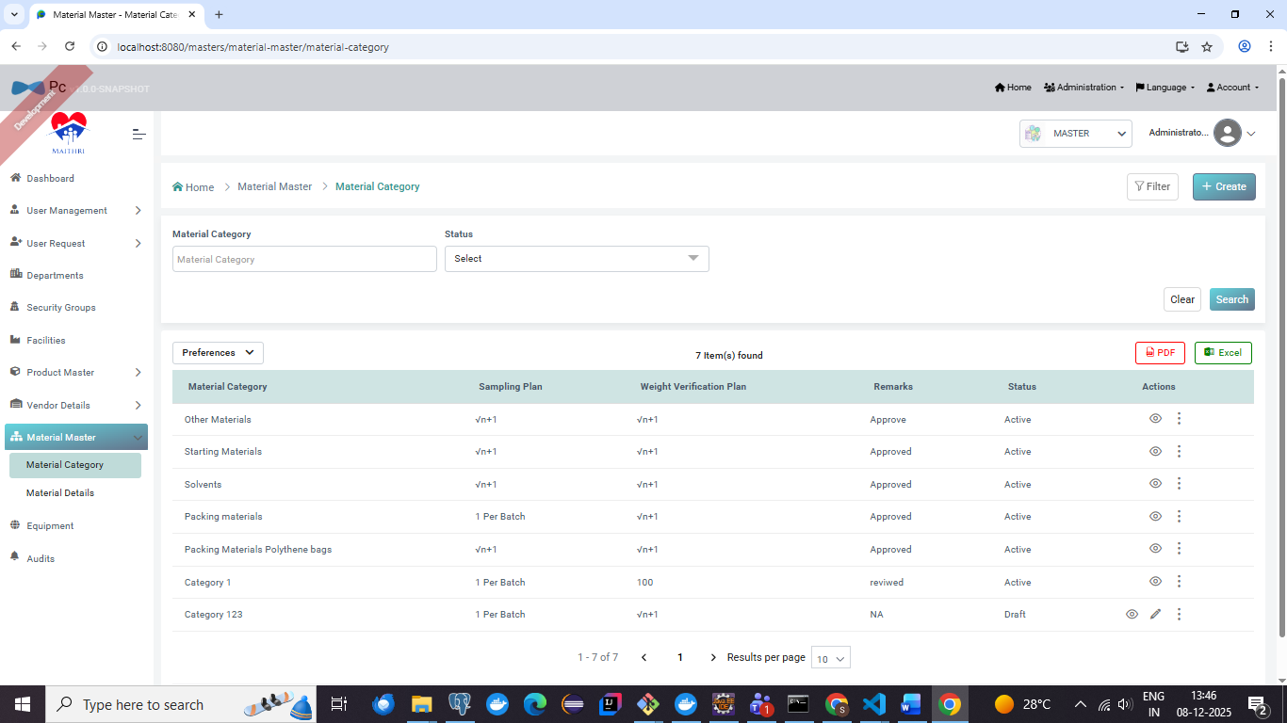

**Screenshot - 09 for step No.4.1.1**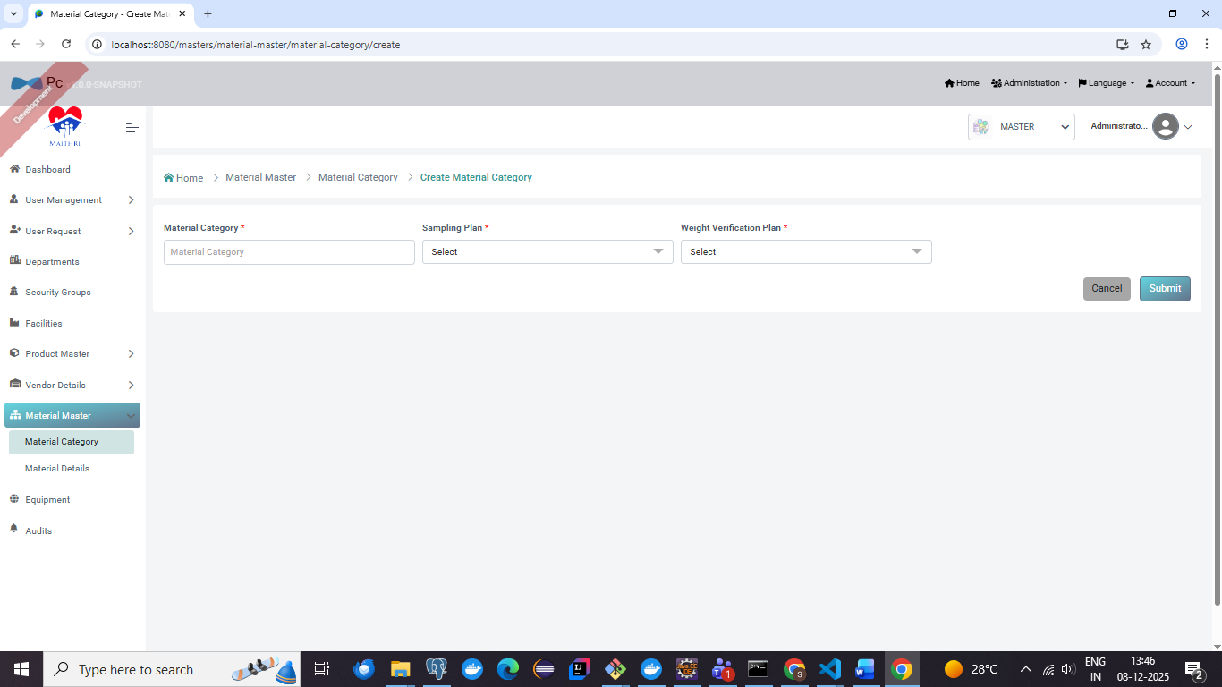

**Screenshot - 01 for step No.4.1.2**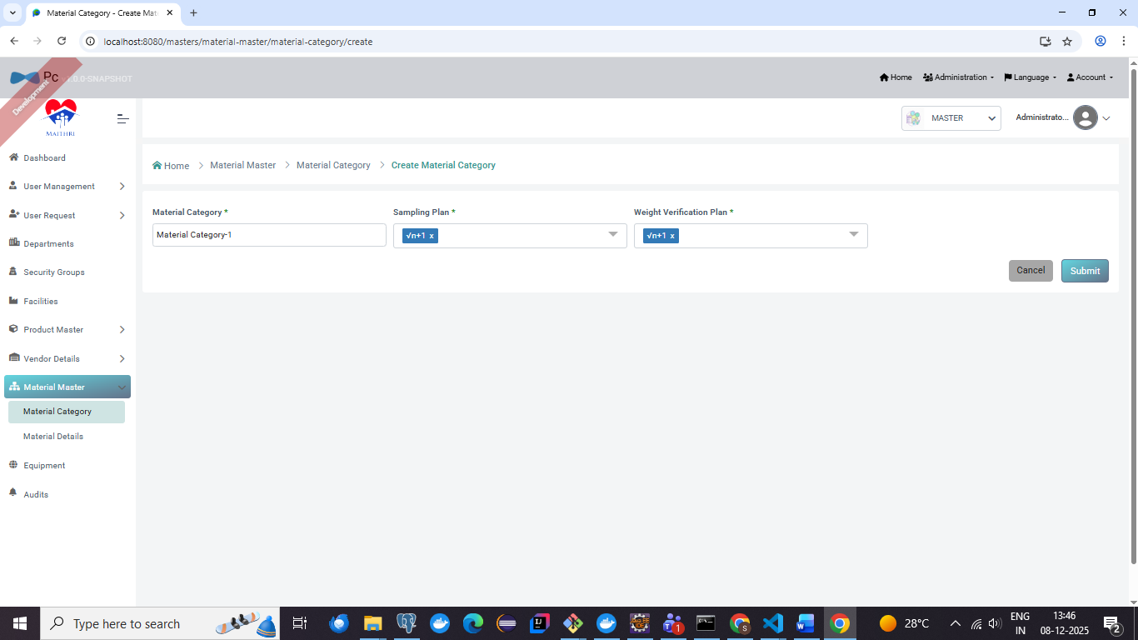

**Screenshot - 02 for step No.4.1.2**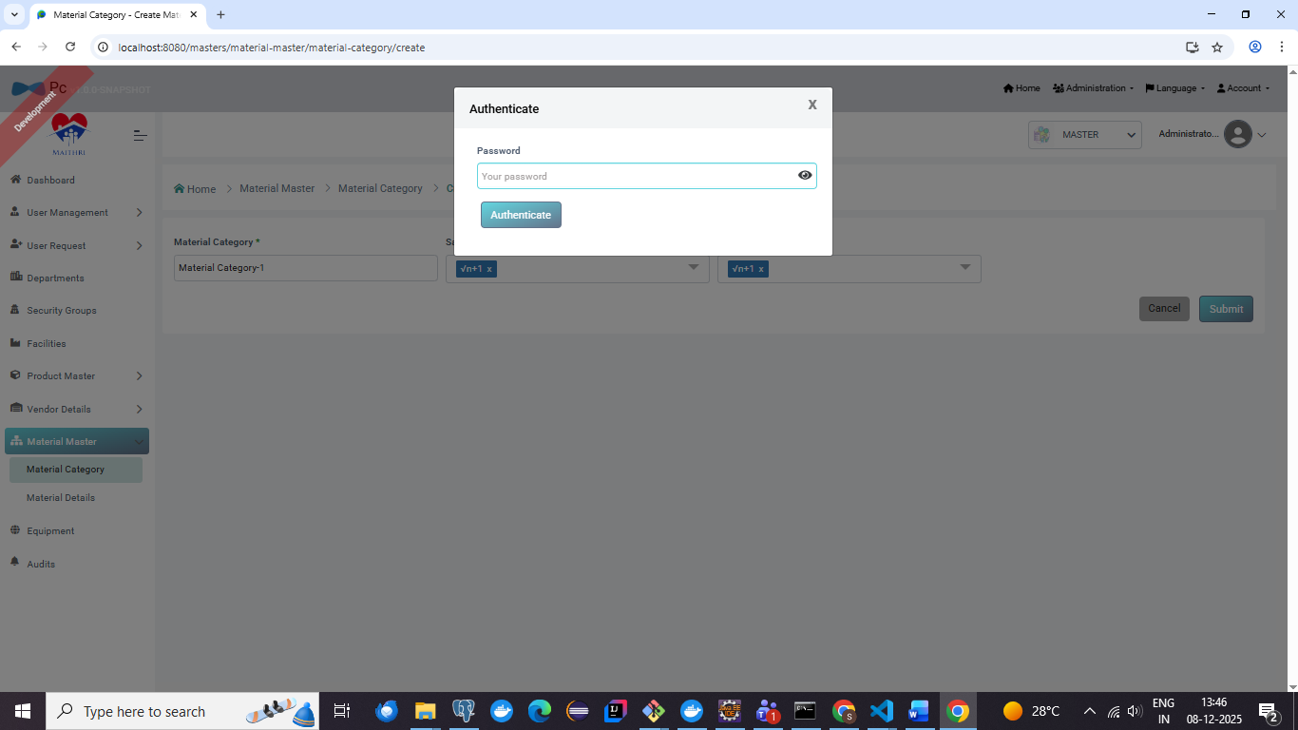

**Screenshot - 03 for step No.4.1.2**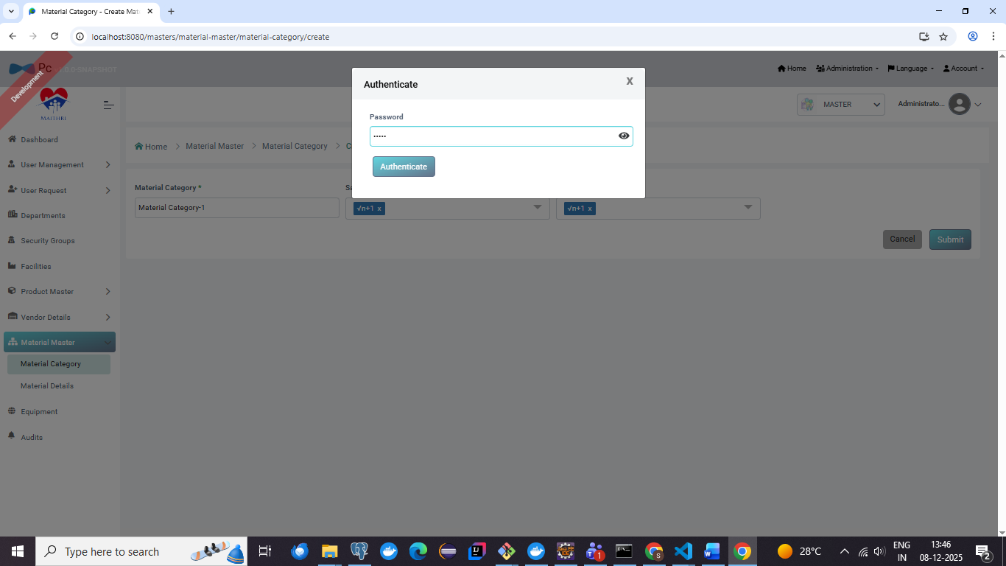

**Screenshot - 04 for step No.4.1.2**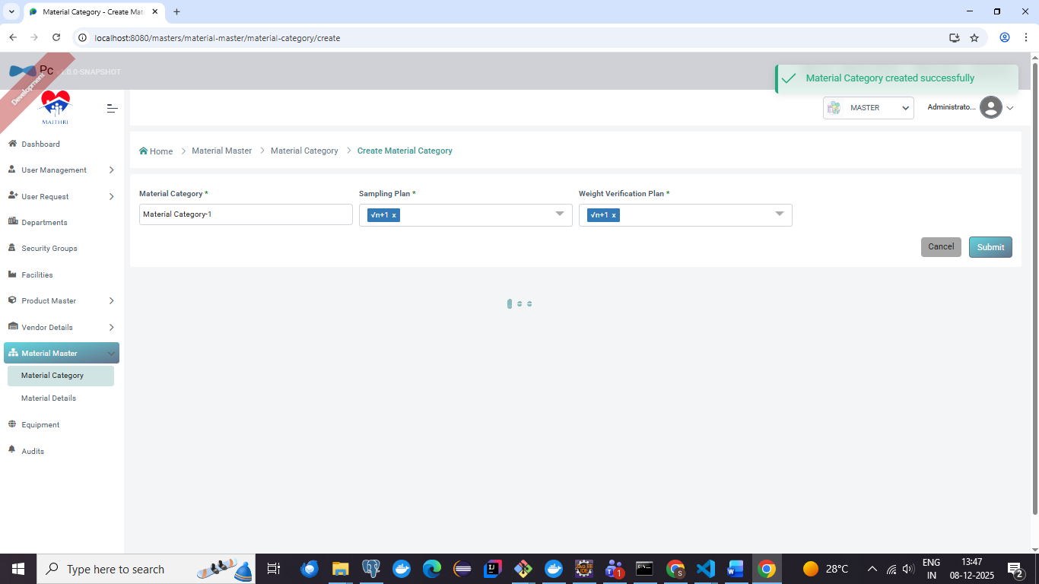

**Screenshot - 05 for step No.4.1.2**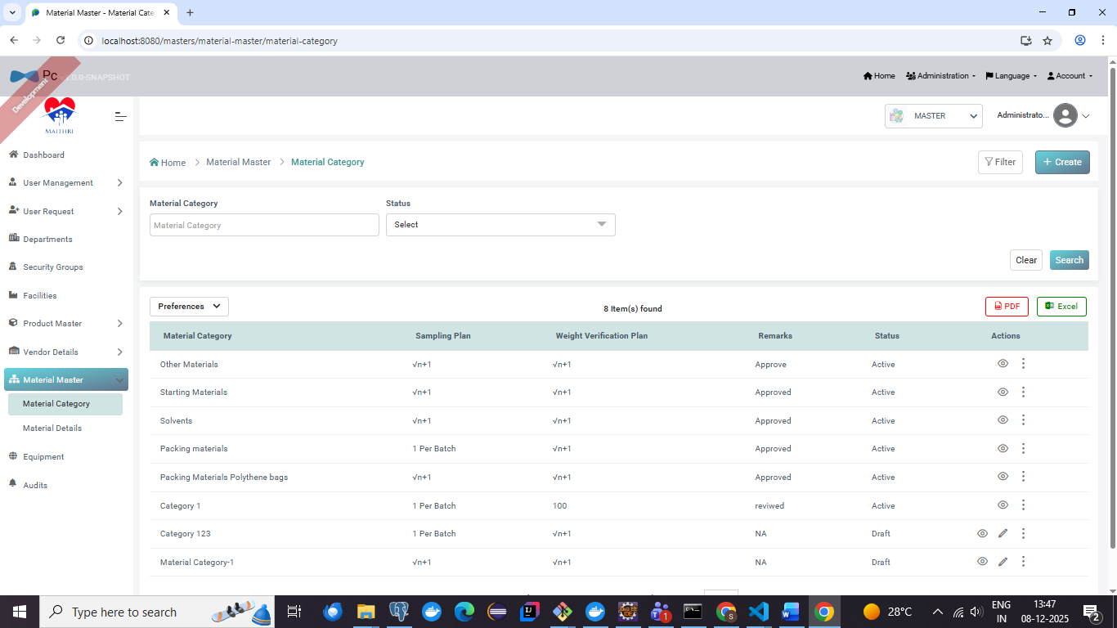

**Screenshot - 01 for step No.4.1.3**

**Screenshot - 01 for step No.4.1.4**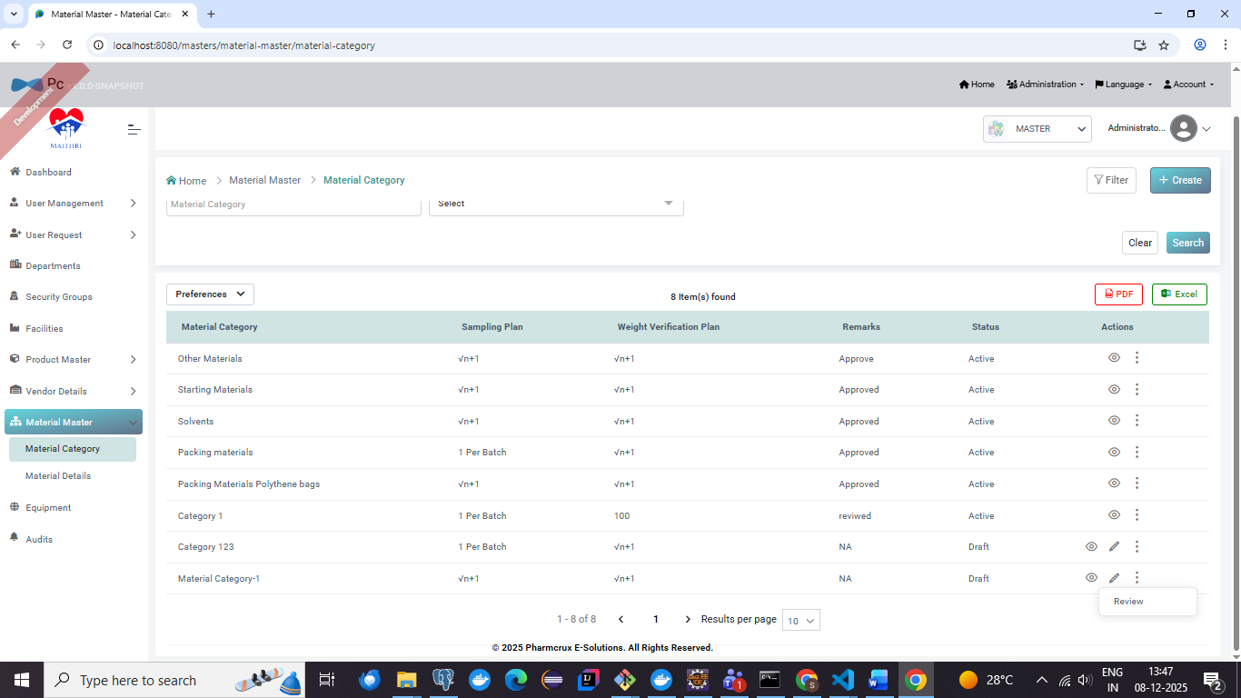

**Screenshot - 01 for step No.4.1.5**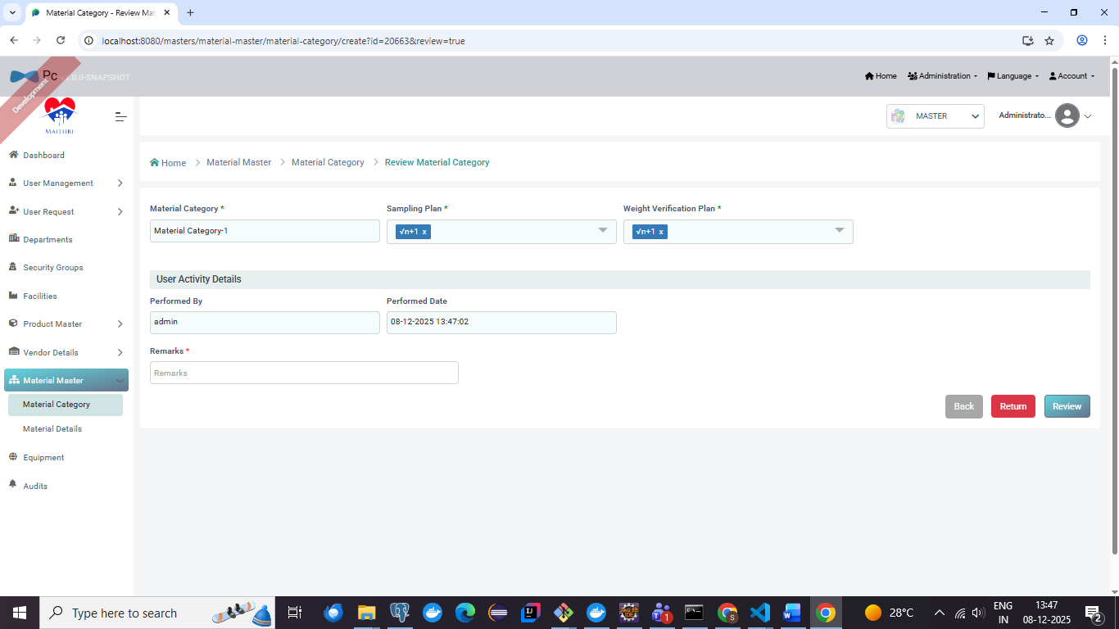

**Screenshot - 02 for step No.4.1.5**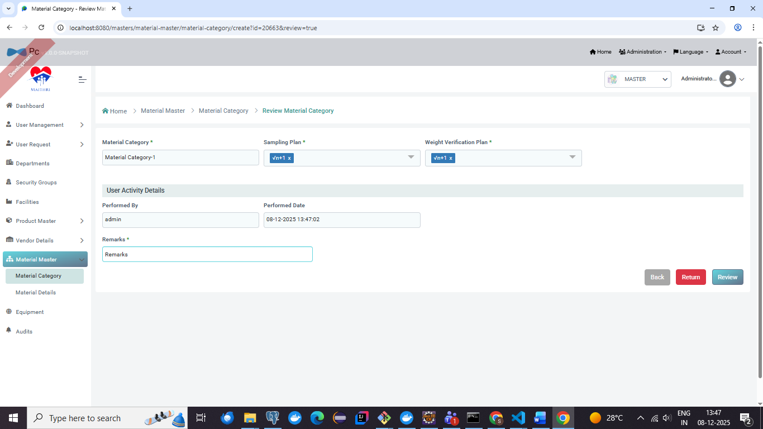

**Screenshot - 03 for step No.4.1.5**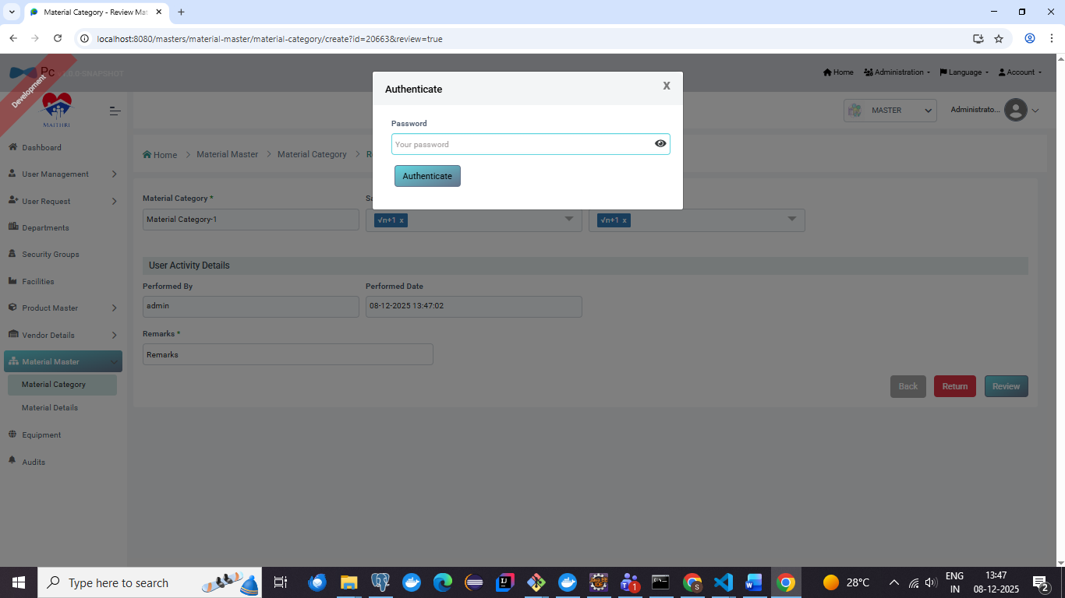

**Screenshot - 04 for step No.4.1.5**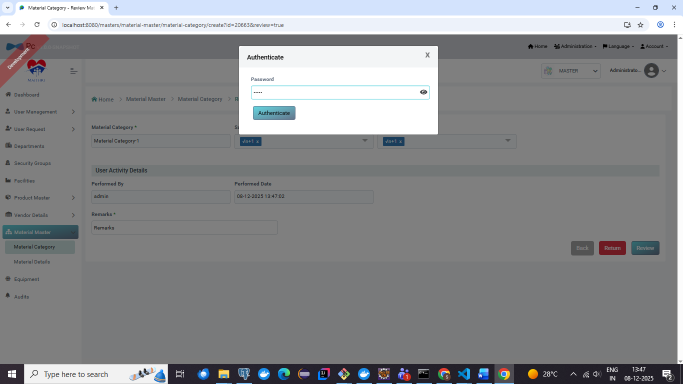

**Screenshot - 05 for step No.4.1.5**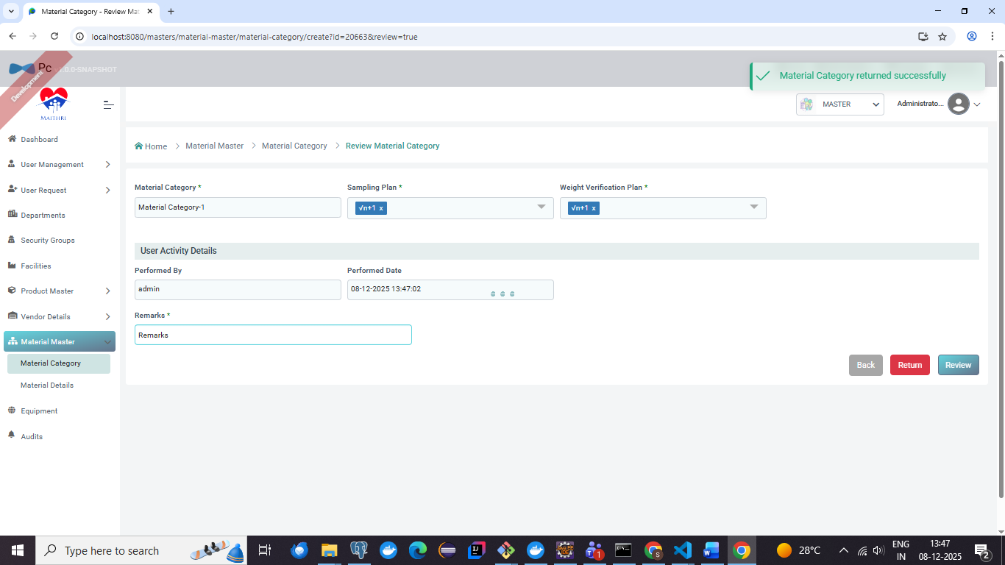

**Screenshot - 06 for step No.4.1.5**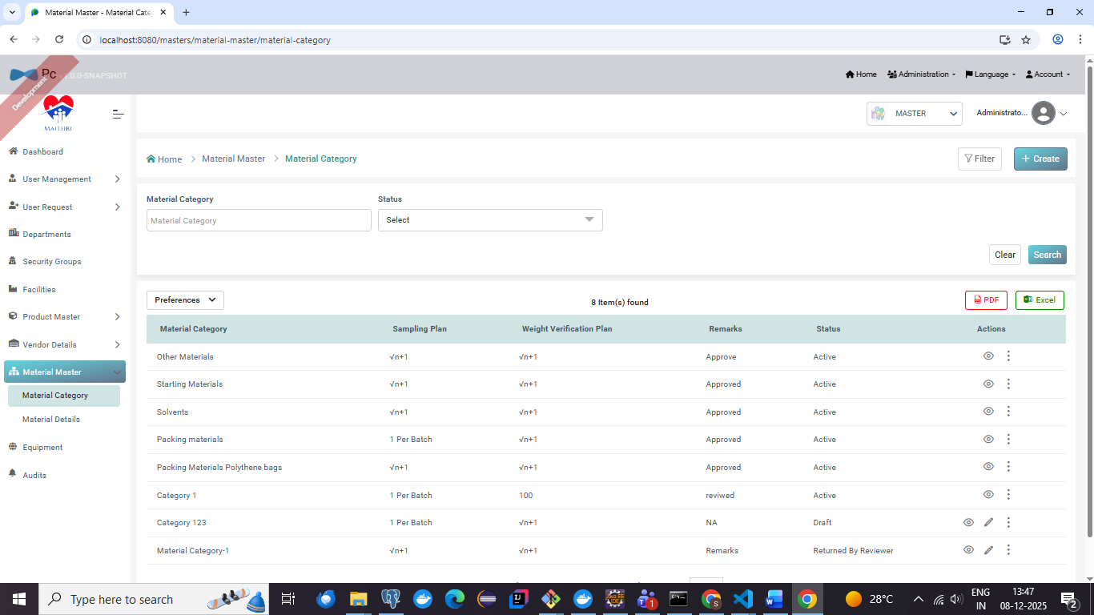

**Screenshot - 01 for step No.4.1.6**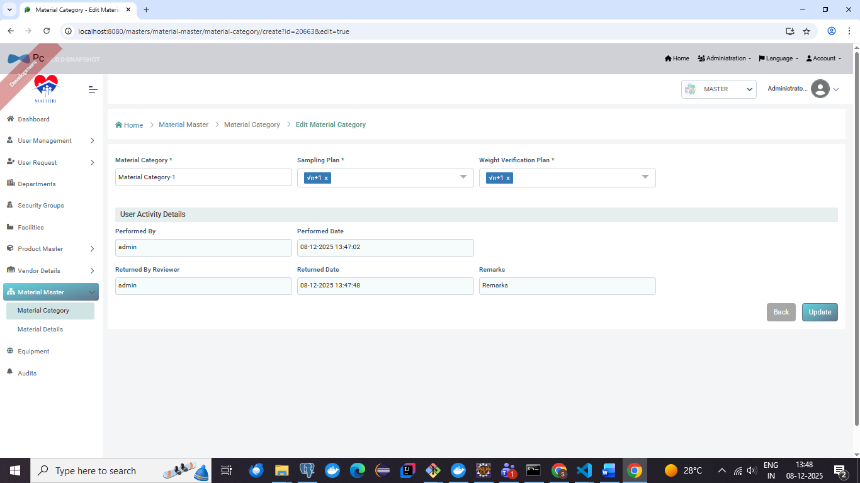

**Screenshot - 02 for step No.4.1.6**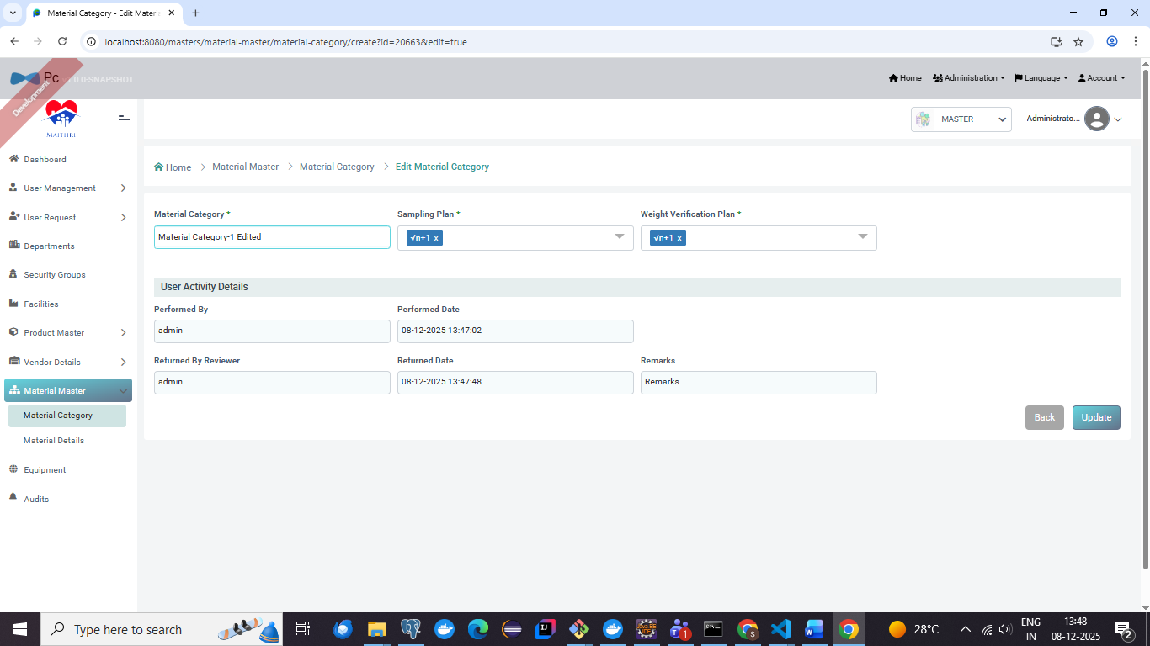

**Screenshot - 03 for step No.4.1.6**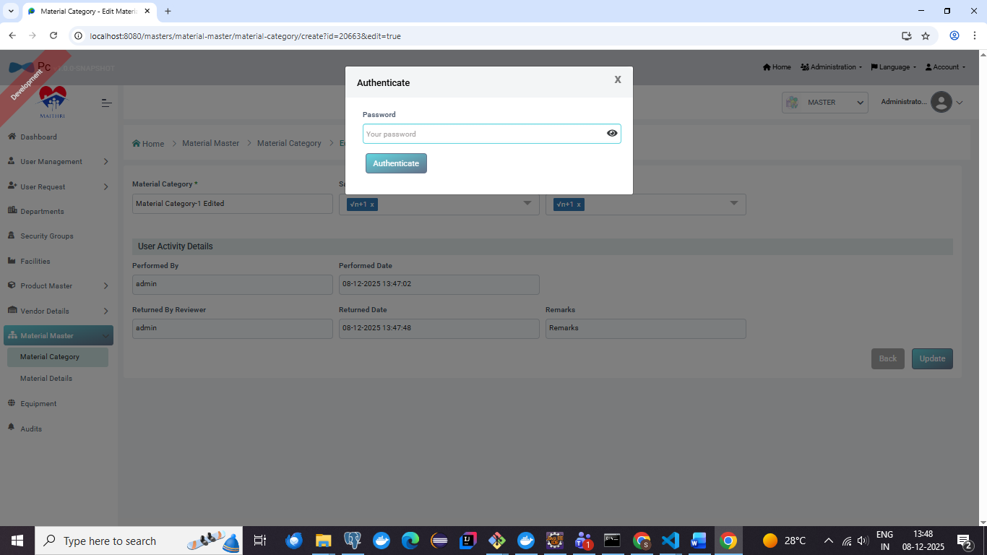

**Screenshot - 04 for step No.4.1.6**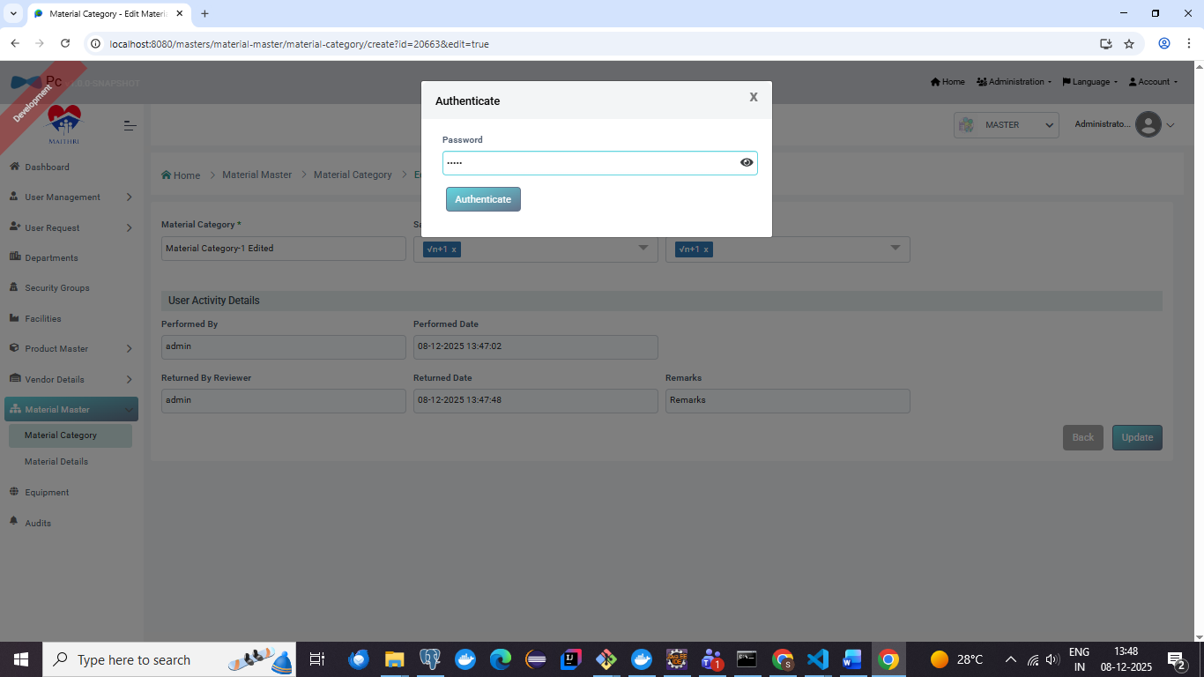

**Screenshot - 05 for step No.4.1.6**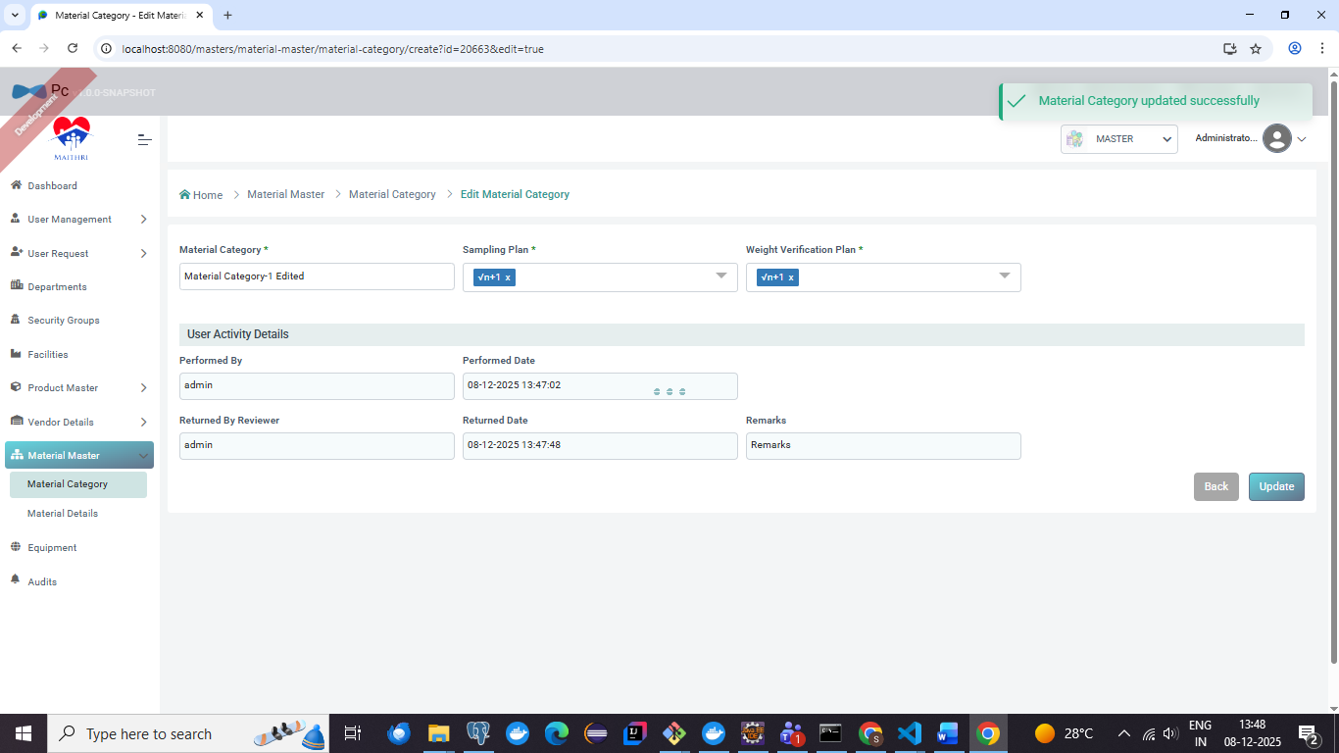

**Screenshot - 06 for step No.4.1.6**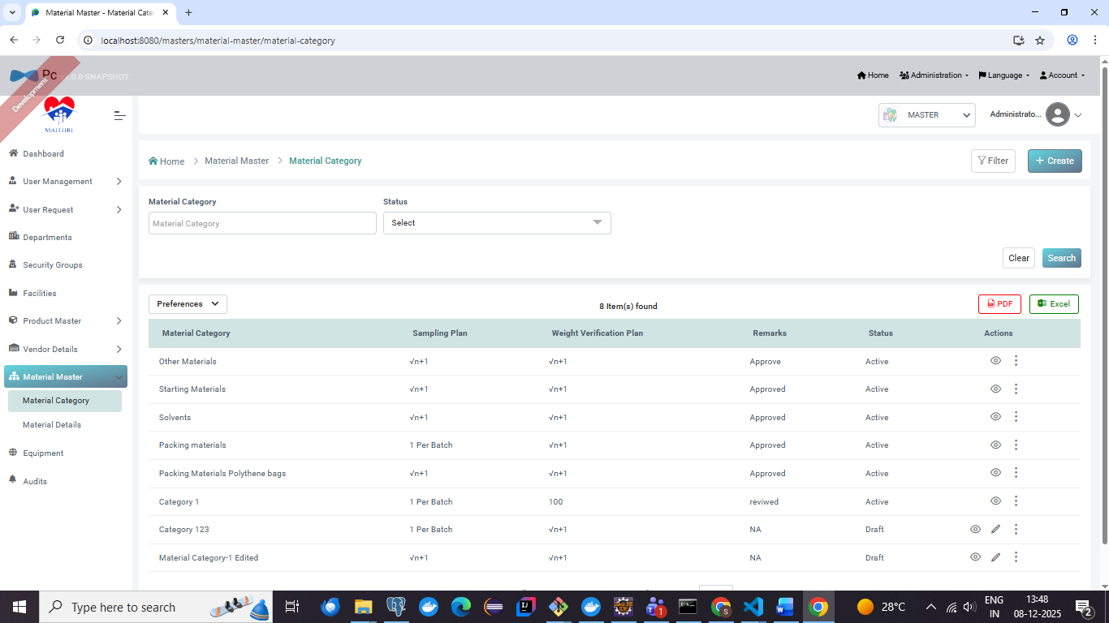

**Screenshot - 01 for step No.4.1.7**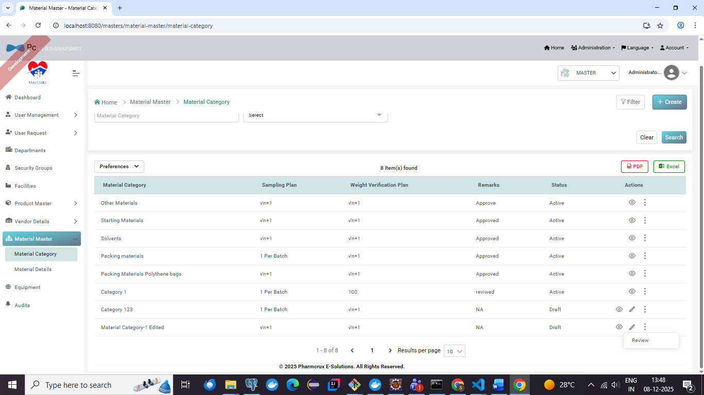

**Screenshot - 02 for step No.4.1.7**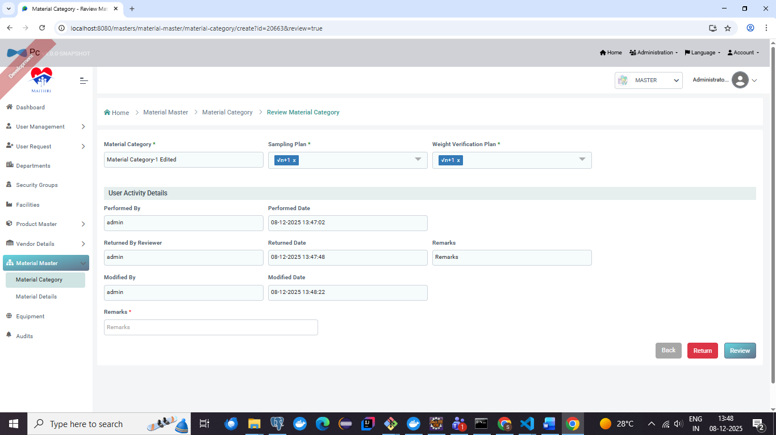

**Screenshot - 03 for step No.4.1.7**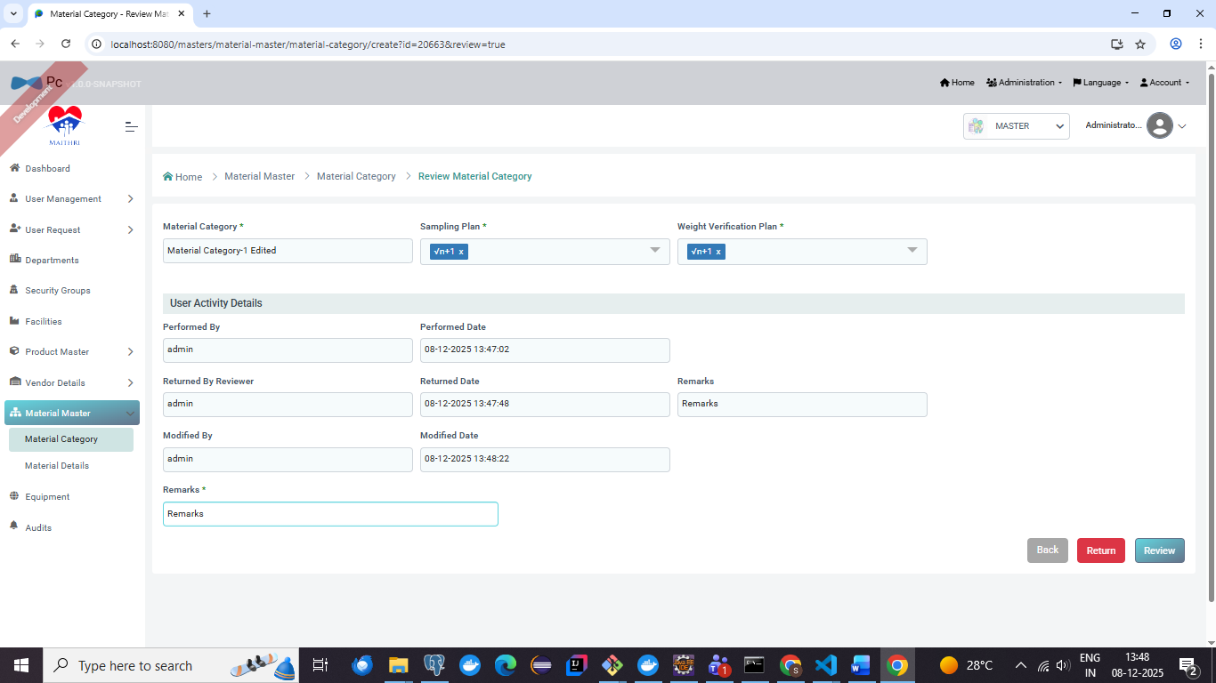

**Screenshot - 04 for step No.4.1.7**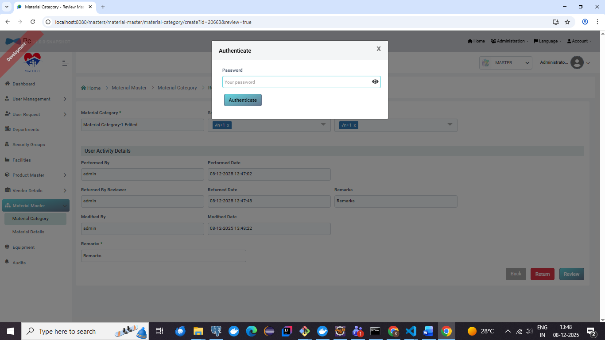

**Screenshot - 05 for step No.4.1.7**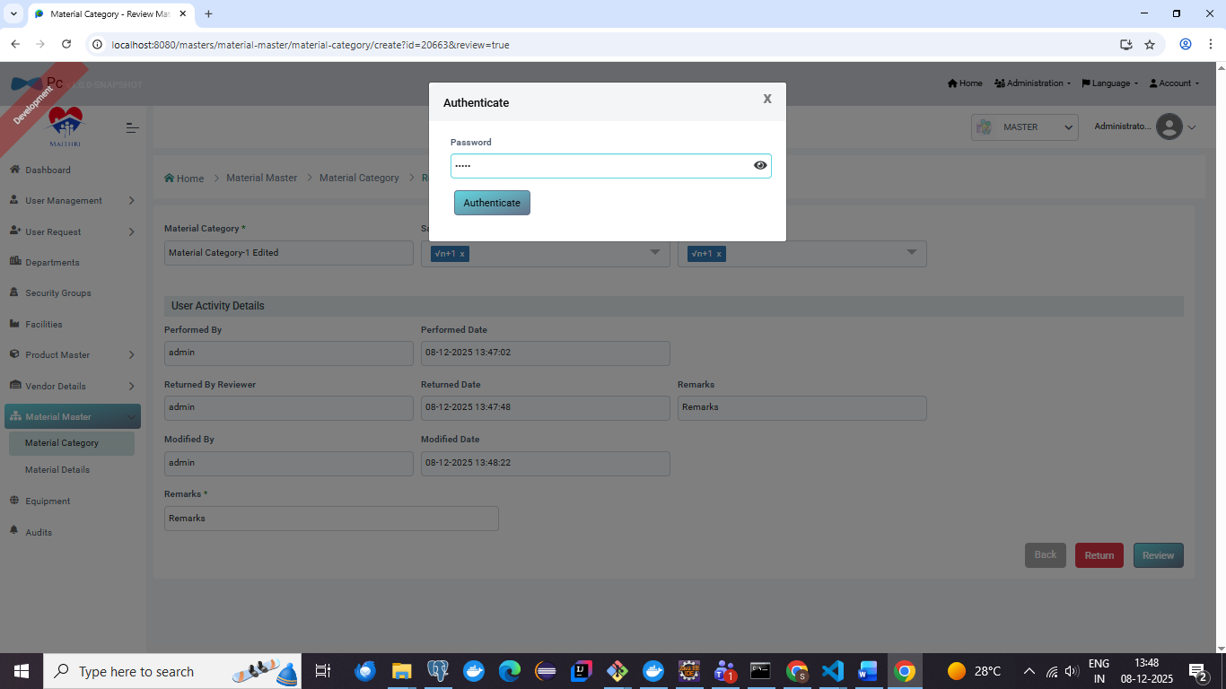

**Screenshot - 06 for step No.4.1.7**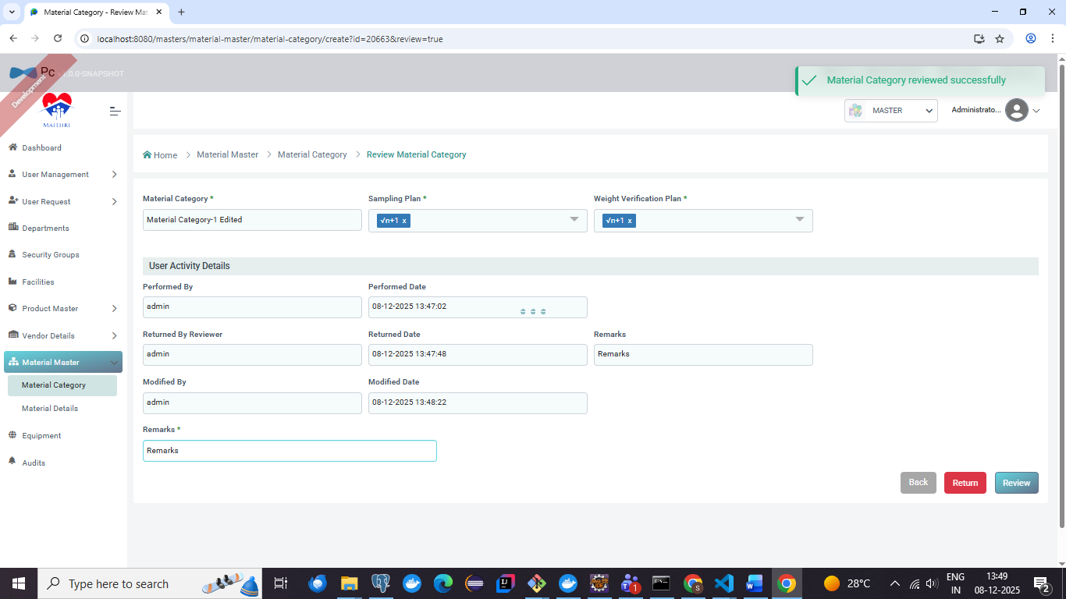

**Screenshot - 07 for step No.4.1.7**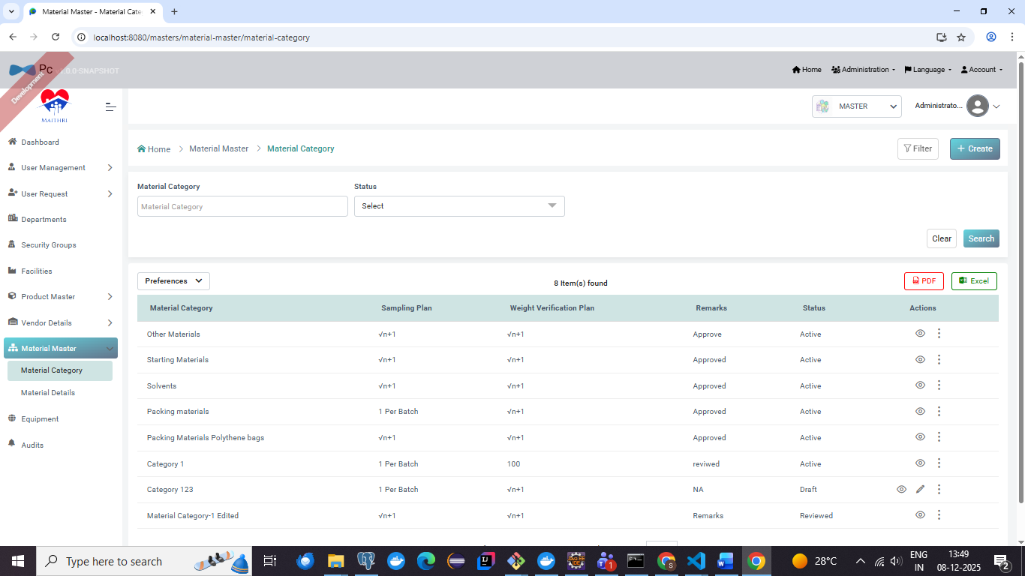

**Screenshot - 01 for step No.4.1.7**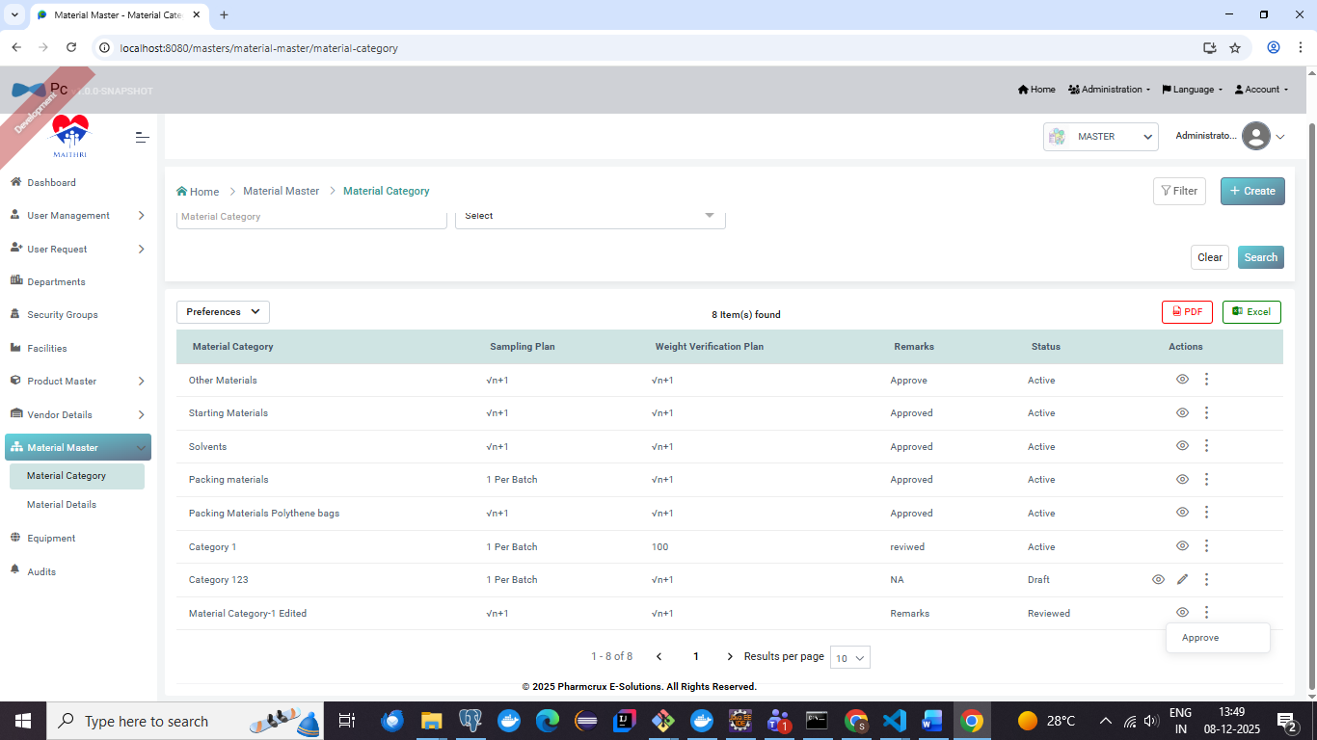

**Screenshot - 02 for step No.4.1.7**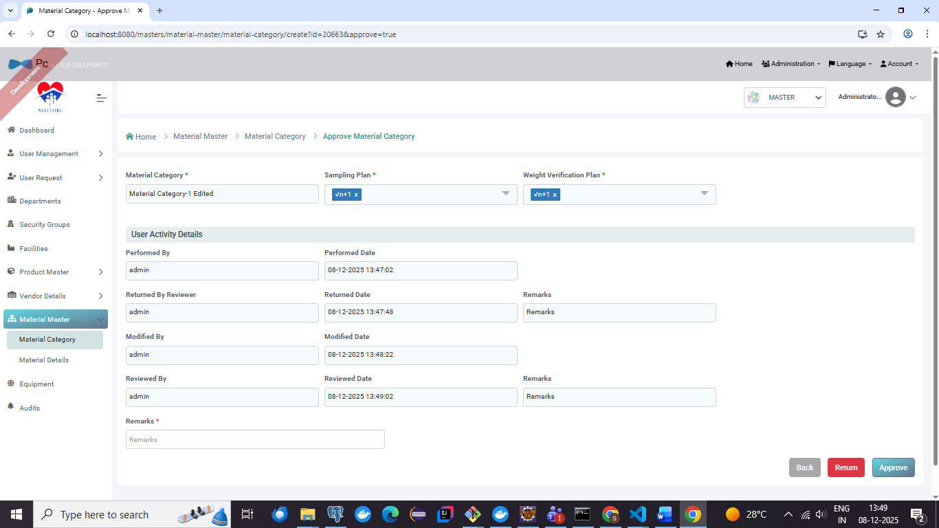

**Screenshot - 03 for step No.4.1.7**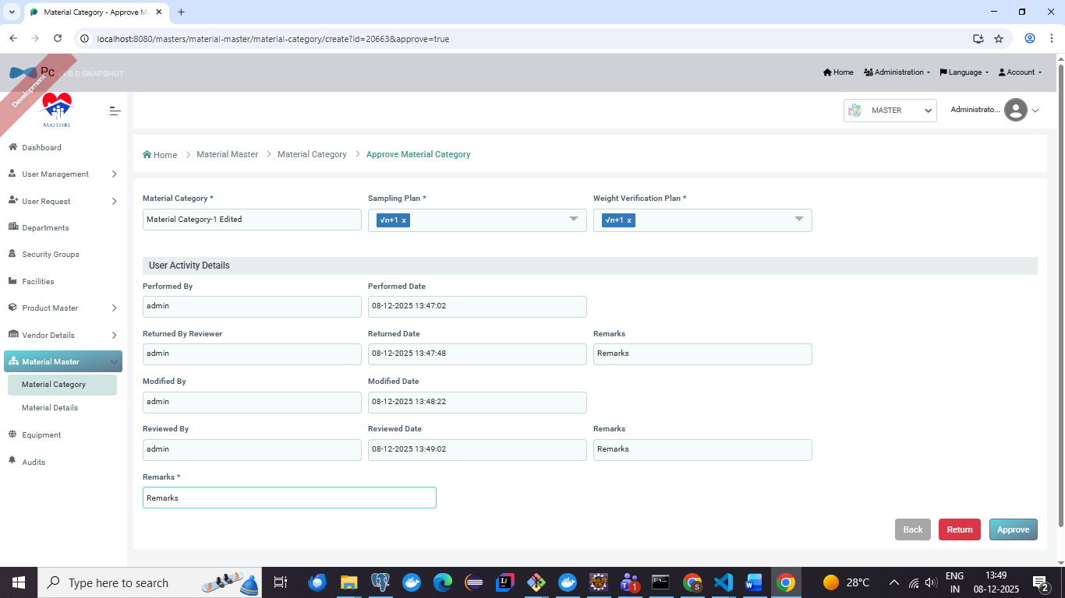

**Screenshot - 04 for step No.4.1.7**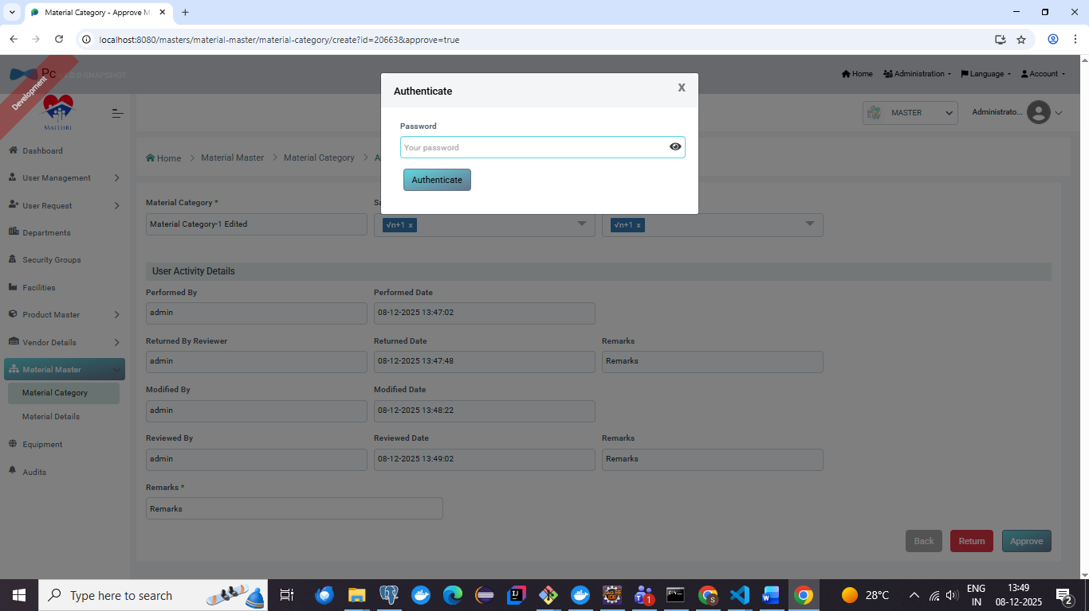

**Screenshot - 05 for step No.4.1.7**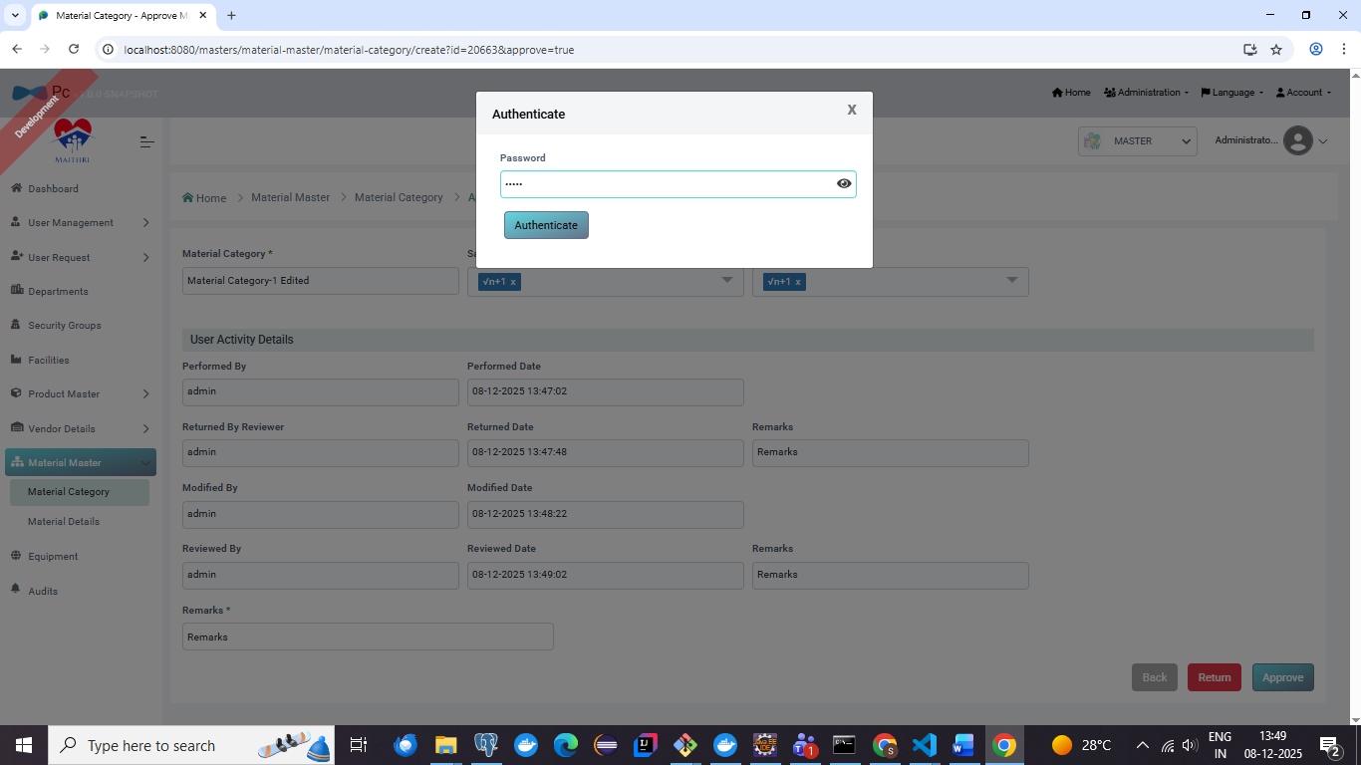

**Screenshot - 06 for step No.4.1.7**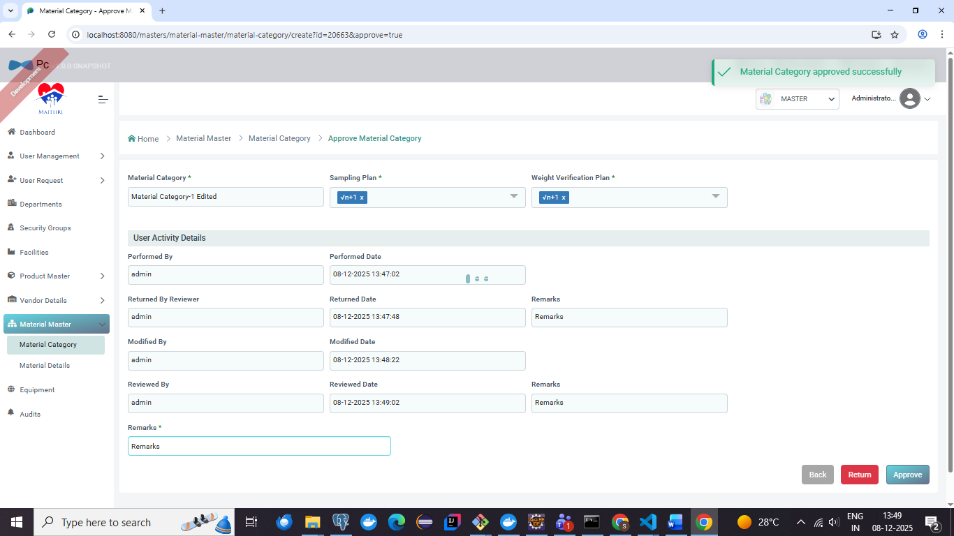

**Screenshot - 07 for step No.4.1.7**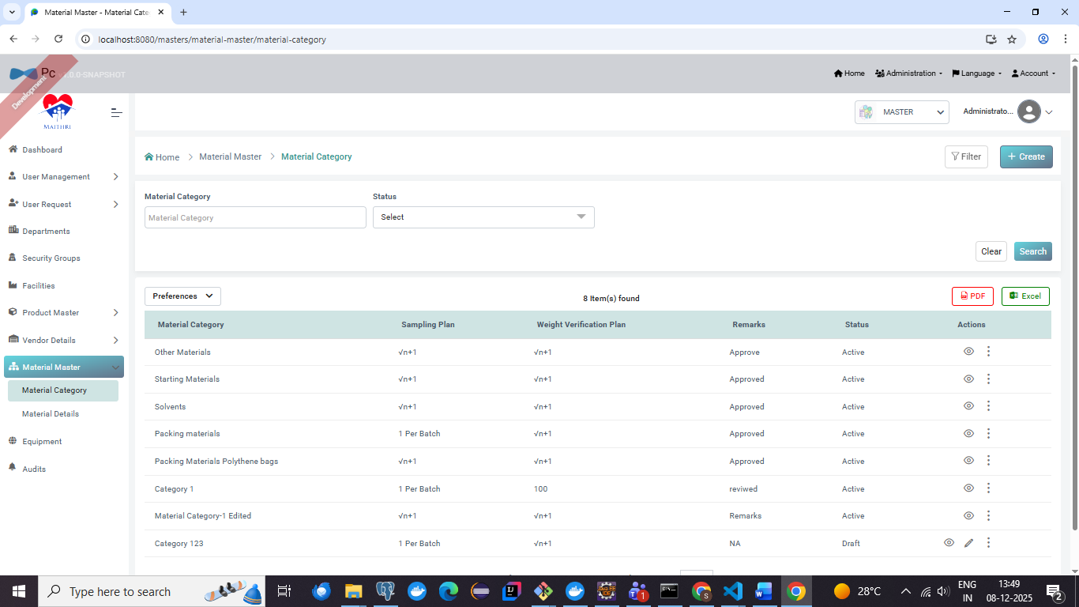

**Screenshot - 01 for step No.4.1.8**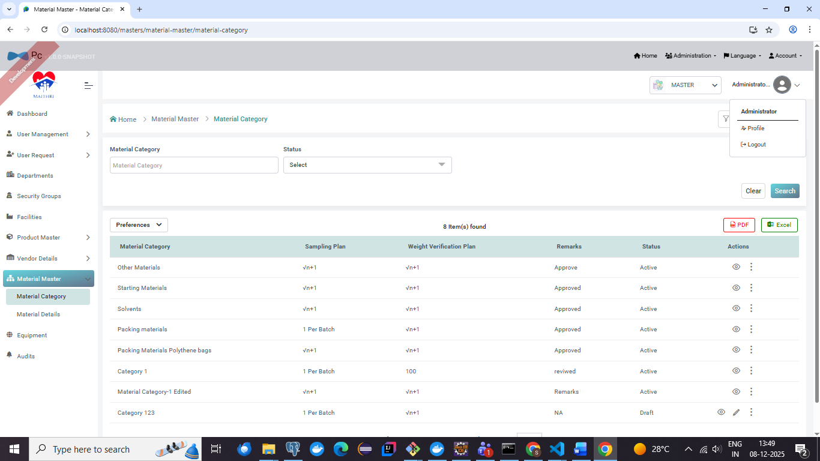

**Screenshot - 02 for step No.4.1.8**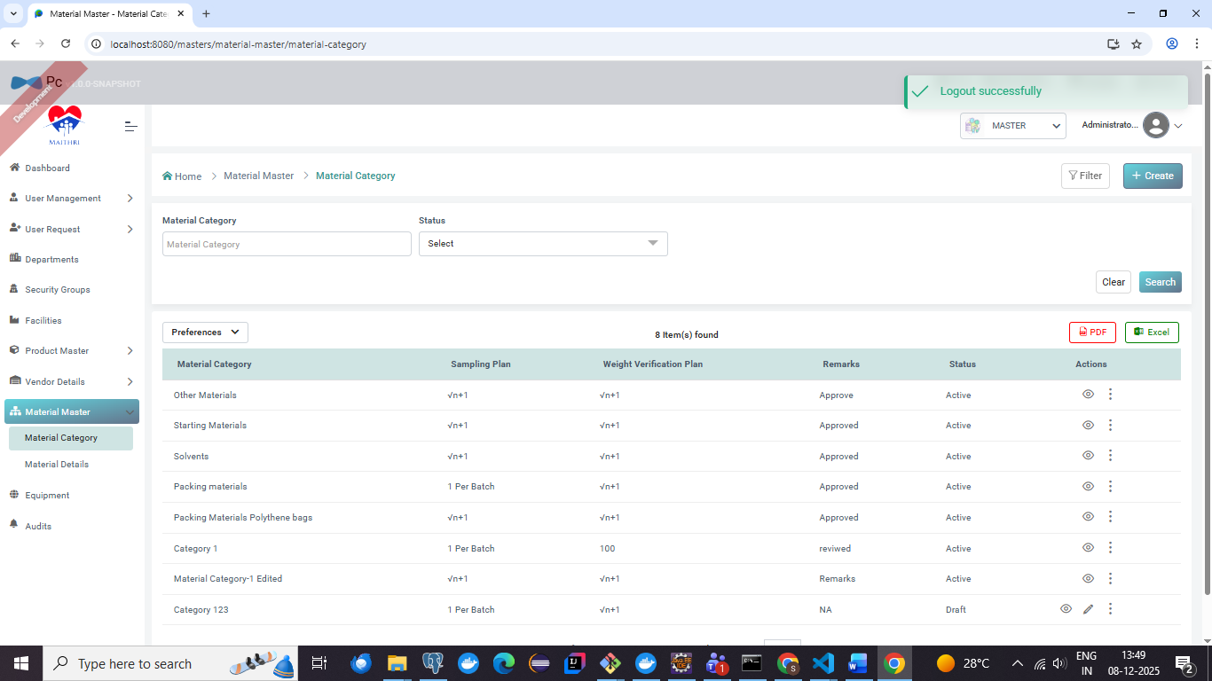

|  |  |  |  |  |
| --- | --- | --- | --- | --- |
| **Test Duration Details:** | **Start Date :** |  | **End Date:** |  |
|  | **Total Screenshots :** |  | **No. of Testers:** |  |
| **Remarks:** | | | | |
|  | | | | |

|  |  |  |  |  |
| --- | --- | --- | --- | --- |
| **Executed by** |  |  |  |  |
| **Name** | **Title, Department** | **Signature** | **Date** |

|  |  |  |  |  |
| --- | --- | --- | --- | --- |
| **Reviewed By** |  |  |  |  |
| **Name** | **Title, Department** | **Signature** | **Date** |

|  |  |  |  |  |
| --- | --- | --- | --- | --- |
| **Reviewed By** |  |  |  |  |
| **Name** | **Title, Department** | **Signature** | **Date** |

|  |  |  |  |  |
| --- | --- | --- | --- | --- |
| **Reviewed By** |  |  |  |  |
| **Name** | **Title, Department** | **Signature** | **Date** |

|  |  |  |  |  |
| --- | --- | --- | --- | --- |
| **Approved By** |  |  |  |  |
| **Name** | **Title, Department** | **Signature** | **Date** |